REGISTERED COMPANY NUMBER: 08031174  
 REGISTERED CHARITY NUMBER: 1147658

THE ENGLISH PROVINCE OF   
OUR LADY OF CHARITY 31 May 2000

# 

**FUNGAL INFECTION TRUST**

**REPORT AND ACCOUNTS**

**30 APRIL 2024**

**FUNGAL INFECTION TRUST**

**INDEX**

**Page**

1 Reference and administrative details

2-7 Trustees’ Report

8 Independent examiner’s report

9 Statement of financial activities

10 Balance Sheet

11-15 Notes to the accounts

16 Appendix

Scientific publications and presentations

**Trustees**  Professor P J Folkman

Mr P G Oxnam

Mr J C Morgan

Dr C Pankhurst

Professor R Hay

**Hon Secretary** Mr J C Morgan

**Bankers** Royal Bank of Scotland

Macclesfield Chestergate Branch

1 Hardman Boulevard

Manchester

M3 3AQ

**Independent Examiner** Roslyn Beattie

Company Solutions Limited

2 Festival Square

Little Germany

Bradford BD1 5BD

**Registered Address**  20 Elsdon Place

St. Georges Wood

Morpeth

Northumberland NE61 2GY

**Charity Registration:** 1147658

**Company Registration:** 08031174

The board of Trustees, who are also directors of the Charity for the purposes of the Companies Act 2006, present their report and financial statements of Fungal Infection Trust for the year ended 30 April 2024. The financial statements have been prepared in accordance with the accounting policies as set out on page 11 and comply with the charity’s trust deed, the Companies Act 2006 and the Statement of Recommended Practice – Accounting and Reporting by Charities 2011.

**STRUCTURE, GOVERNANCE AND MANAGEMENT**

The Fungal Infection Trust (“The Charity” or “The Trust” or “FIT”) is a company limited by guarantee and governed by its Memorandum and Articles of Association.

**DIRECTORS AND TRUSTEES**

The directors of the charitable company are its Trustees for the purpose of charity law and throughout this report are collectively referred to as the Tr**ustees**.

**The Trustees serving during the year were as follows:**

**Mr P G Oxnam Chairman**

**Mr J C Morgan Secretary**

**Professor P J Folkman**

**Professor R Hay**

**Dr C L Pankhurst**

New Trustees are interviewed and appointed by the existing Trustees.

**Risk Management**

The Trustees have examined the major strategic, business and operational risks which the charity faces and confirm that systems have been established to enable regular reports to be produced so that the necessary steps can be taken to lessen these risks.

**Organisational Structure and Governance**

The Trust is managed by the Trustees. The Trust has no paid or voluntary employees. Accounts are prepared by the Secretary on a regular basis and presented to the Trustees at their meetings. The financial status of the Trust is reviewed by a Trustee sub-committee prior to each Trustees’ meeting and its recommendations presented to the meeting. A minimum of three Trustees meetings are held each year.

**Responsibilities of Trustees**

Law applicable to charities in England & Wales requires the Trustees to prepare financial statements for each financial year which give a true and fair view of the incoming resources and application of the resources of the charity during the year and of its state of affairs at the end of the year. In preparing financial statements giving a true and fair view, the Trustees recognise they should follow best practice and:

* select suitable accounting policies and then apply them consistently;
* make judgements and estimates that are reasonable and prudent;
* state whether applicable accounting standards and statements of recommended practice have been followed;
* prepare the financial statements on the going concern basis unless it is inappropriate to presume that the charity will continue in operation.

The Trustees are responsible for keeping proper accounting records which disclose with reasonable accuracy the financial position of the charity and which enable them to ascertain its financial position and to ensure that the financial statements comply with the Companies Act 2006 and the Statement of Recommended Practice – Accounting and Reporting by Charities 2005 and the Trust Deed. They are also responsible for safeguarding the assets of the charity and hence for taking reasonable steps for the prevention and detection of fraud and other irregularities.

**OBJECTIVES AND ACTIVITIES**

1. To promote research in all aspects of mycology, mycotic diseases, fungal toxicology and microbial disease (of all living things) and to publish the useful results thereof.
2. To advance education particularly among physicians and scientists about mycology, mycotic diseases, fungal toxicology and microbial diseases in general.
3. To generally support basic research into fungi and fungal disease, train scientists in mycology and related disciplines.
4. To provide information to patients suffering from fungal diseases, in particular aspergillosis*.*
5. To raise awareness of fungal pathogens and fungal diseases amongst the general public in the UK and internationally*.*

**Review of Activities Review of Activities**

The FIT website ([www.fungalinfectiontrust.org](http://www.fungalinfectiontrust.org)) recorded a slight fall in traffic from about 660 visitors per month in 2022 to early 2023. to an average of 465 unique visitors per month in 2023-mid 2024. The most popular pages after the home page are Skin, hair and nail infection, Research grants, What we do, and the links to the Aspergillus Website. and Microfungi.

The rise of ‘fake news’ and other online uncurated sources increases the value of the trusted FIT’s authoritative fungal disease online resources.

Online education in fungal microscopy and histology ([www.microfungi.net/](http://www.microfungi.net/))

The FIT supports the world’s first online Microscopy and Histology course. To date this course has hosted nearly 5,000 distinct users from over 130 countries, a 61% increase in users over the year 2022-2023. This can be attributed to the targeted marketing that has taken place to promote the new updated resources in Modules 2 and 3. Translation of the resource updates were completed for French, Spanish, and Portuguese, with Chinese in progress. In 2023 alone, almost 5,000 individual sessions were recorded on the platform. Microfungi has a global reach. With over 110 different countries represented. The main audiences are shown in the table.

Those registered on the course can re-enter the course at any time to refresh their knowledge. This makes microfungi an invaluable life-long learning tool for all healthcare practitioners.

The Aspergillus Website ([www.aspergillus.org.uk](http://www.aspergillus.org.uk))

The Aspergillus Website celebrated its 25th year in 2023. The Aspergillus Website is the world’s most comprehensive resource for the pathogenic and allergenic fungi Aspergillus and all the diseases this group of fungi cause. It is completely free to all users.

The Aspergillus Website is still read very widely across the world. It has about 6,500 unique visitors monthly, which is a slight fall from previous years, but this usage does not record all the users of the drug interaction database.

The Aspergillus Website provides free easy access to >74,000 pages, over 16,200 scientific articles (including a unique collection of 836 historical articles) and over 17,320 conference abstracts from 1974 onwards.

The Aspergillus Website hosts a comprehensive list of drug-drug interactions with antifungals which is continually updated. This drug interaction database [(www.aspergillus.org.uk/antifungal-drug-interactions/](http://(www.aspergillus.org.uk/antifungal-drug-interactions/)) (including the antifungal drug interaction app for android phones) is popular and well used. The database as of May 2023 hosted interactions between 1628 licensed drugs and 13 systemic antifungal agents (a total of 21,164 possible interactions).

In 2023, 50 newly registered drugs were added into the database, with new entries reflecting the interactions that exist with the antifungal agents. In addition 32 entries were updated with new information. The new antifungal ibrexafungerp was added. The support software was also updated to provide greater stability.

A major review paper was published in April 2024, that had at its core data from the Antifungal Drug Interaction database (see below).

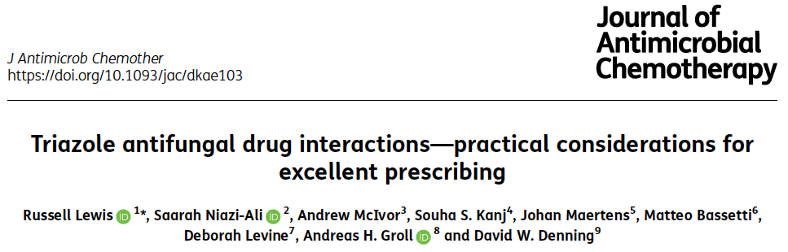

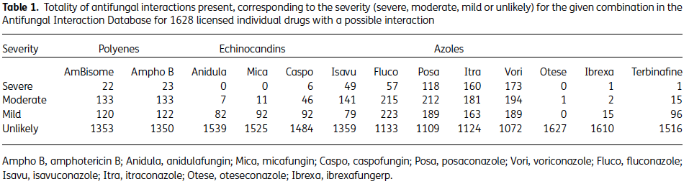

In a typical quarter, there are 700 users of the antifungal interactions website, most new users. The greatest number of users are from the UK, USA, China, Canada, Germany, Australia and Brazil.

Leading International Fungal Education (LIFE) ([www.fungaleducation.org](http://www.fungaleducation.org))

Education of healthcare professionals is a key need to improve diagnosis and therapy. The LIFE website has been operating since 2012 with the objective of providing education on this highly specialised topic for clinicians ([www.LIFE-worldwide.org.uk](http://www.LIFE-worldwide.org.uk)). The English language version is predominantly viewed from USA, India, UK, Nigeria, Philippines, Canada, with China falling below the top 10 countries. There has been substantial growth of usage from SE Asia with over 42,000 users (a >500% rise). The whole LIFE website is also available in Spanish, with over 5,500 users from Mexico, Spain, Colombia, USA, Peru and Argentina.

The most popular pages on the English version are the fungal culture, microscopy, *Trichophyton*, clinical guidelines, otomycosis, tinea, histopathology, fungus ball of the sinuses and *Candida* spp. different from the previous year.

On the Spanish version, the most popular pages are dimorphic fungi, otomycosis, tinea imbricata, fungal education, *Candida*, *Trichophyton*, Beta 1.3 glucan, jobs and careers, *Aspergillus,* *Rhodotorula*, again different from the previous year.

LIFE’s YouTube channel was setup in 2017 and has 4,700 subscribers

([www.youtube.com/channel/UCMbjRZb4EofRTkKK9yHU8qQ](http://www.youtube.com/channel/UCMbjRZb4EofRTkKK9yHU8qQ)). It continues to be a very important component of the LIFE Worldwide educational offering. It hosts 111 videos which have been watched >517,000 times with 95,000 views in the last year. There is still widespread interest in the antifungal medication videos, but there has been a surge in interest in tinea capitis and our featured skin incision videos.

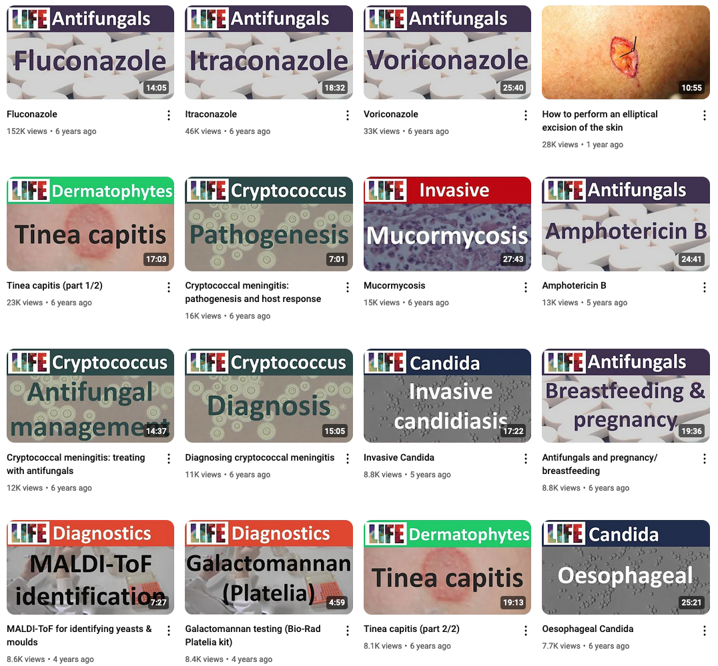

LIFE manages a separate twitter account which has grown its followers over the last year by 10% to ~2,600. Although we have continued to use our Twitter channel as a method of communication, 2023-24 has seen a real drop off in scientific interest on the platform. There are noticeably fewer mycology colleagues, and scientists in general, using this platform due to the increased politicisation and rise in advertising on Twitter (now called X). Our engagement figures are much reduced when compared to 2022-23. In 2022-23 we received over 110k impressions, but in 2023-24 this has fallen to 50k. For 2024-25 LIFE will focus on exploring other social media platforms to access our audience.

Burden of fungal disease estimates

A component of the LIFE effort has been to boost awareness of fungal infections generally, by quantifying the problem better. This has involved estimating the burden of serious fungal disease in over 100 countries, to highlight the seriousness of a range of primary and secondary fungal diseases. Repeat estimations for Uganda was published in the last year. Additions since last year’s report are underlined.

* Published in journals (x87): Algeria, Argentina, Austria, Azerbaijan, Bangladesh, Belgium, Brazil, Burkina Faso, Cameroon, Canada, Caribbean, Chile, China, Colombia, Congo (Republic of), Cote d’Ivoire, Czech Republic, Democratic Republic of Congo (DRC), Denmark, Dominican Republic, Ecuador, Egypt, Eritrea, Ethiopia, France, Germany, Ghana, Greece, Guatemala, Honduras, Hungary, India, Indonesia, Iran, Ireland, Israel, Italy, Jamaica, Jordan, Kazakhstan, Kenya, Kuwait, Kyrgyzstan, Malawi, Malaysia, Mali, Mexico, Morocco, Mozambique, Namibia, Nepal, Netherlands, Nigeria, Norway, Oman, Pakistan, Panama, Peru, Philippines, Portugal, Qatar, Romania, Russia, Senegal, Serbia, Sierra Leone, South Africa, Spain, Sri Lanka, Sudan, Sweden, Taiwan, Tajikistan, Tanzania, Thailand, Togo, Trinidad and Tobago, Tunisia, Turkey, Uganda (updated), UK, Ukraine, United Arab Emirates, Uruguay, Uzbekistan, Vietnam and Zimbabwe. Published burden papers are available at <https://www.gaffi.org/media/academic-papers/>.
* Presented in abstract/poster form at conferences but not yet published (x13): Australia, Belarus, Benin, Iraq, Japan, Madagascar, Mongolia, New Zealand, Paraguay, Saudi Arabia, Singapore, Venezuela, Zambia (detail is available on the LIFE website in the news section <http://www.life-worldwide.org/media-centre/news>).

The FIT also supported several important research publications and reviews (see Appendix 1). There were 10 peer-reviewed publications in calendar year 2023 consequent to FIT grants and collaborations. The notable outputs include:

* A comprehensive review of invasive aspergolliosis after kidney transplantation.
* An overview of histoplasma in bats, the major source of histoplasmosis, with many gaps in knowledge.
* A systeamtic review of the treatment outcomes of mucomycosis, finding that surgery is critical, and that both posaconazole and isavuconazole alone are partially successful, but the combination of one of them, with amphotericin or immediately after amphotericin produces much better outcomes.

During the year support was given to research projects at the University of Manchester, the University of Ghana and Semmelweis University, Budapest, Hungary. Travel and Living Allowance Grants for attendance and presentation at scientific conferences are part of the Trust’s policy to support scientists in the early stages of their careers in mycology.

A fund has been established in memory of the Trust’s former chairman the late Professor Geoff Scott. The Geoff Scott Travel and Scholarship Fund. A donation to this Fund was received from the Infection Medical Chambers Partnership. Grants were awarded from this fund to researchers from India. Greece and The Czech Republic to attend the Advances Against Aspergillosis and Mycology conference in Milan, Italy.

**Who benefited from the Trust’s Activities?**

Researchers in the study of fungi (mycology), respiratory medicine and infectious diseases from all over the world

Medical doctors, especially through the Drug Interactions database

Patients and their carers.

Students of medicine, pharmacy, biology and microbiology

The public – school children, their teachers and parents.

How do the Trust’s Activities Benefit the Public?

Awareness of fungal disease remains low among the general public. The FIT website enables the public to access reliable information quickly on this topic, augmented by the more specialised web resources at LIFE-Worldwide and the Aspergillus Website. The FIT website also re-posts press and general stories and explanatory articles for easy access for all.

**Future plans**

In 2024/5, translations of the Microfungi educational website into Chinese will be completed. Efforts to promote the FIT online education and professional support resources continue at major conferences in Europe, USA, Asia and Africa, via online talks, distribution of brochures and direct contact with healthcare practitioners. The Aspergillus Website and the drug interaction portal will continue to be updated weekly. Several UK-based public engagement events are planned. The FIT will respond to grant requests as it has done previously.

**FINANCIAL REVIEW,**

The results for the period are set out on page 9. There was a surplus of Income over Expenditure for the year of

£224 (2023 £(23,008)). Corporate Governance expenditure represented 6.84% of total income (2023 10.48%).

During the year grants and donations to support the Aspergillus and LIFE websites were received from the charity Advance Against Aspergillosis and the pharmaceutical companies Pfizer, Gilead, Shionogi and Mundipharma.

**Investment Policy**

The Trustees do not consider that they have sufficient free reserves to invest surplus funds for any medium to long term. Consequently, funds are maintained in a bank deposit account

**Reserves Policy**

The charity have established a policy to maintain unrestricted funds not committed or invested in fixed assets i.e. ‘free reserves’ at a level of between one and two years of unrestricted expenditure. This provides sufficient levels of funds to be able to continue the current activities of the charity and to provide sufficient time to consider and replace existing funding sources should there be a significant change in present funding arrangements.

The reserves policy is reviewed annually**.**

**Secretariat**

The Trustees wish to express their appreciation of the work undertaken by Mr J Morgan in running the secretariat and administrative functions of the Trust during the past year.

**Independent Examiner**

In accordance with the Trust Deed, a proposal to re-appoint Company Solutions Limited for the forthcoming year will be put to the general meeting.

On behalf of the Trustees

Phillip Oxnam 3 September 2024