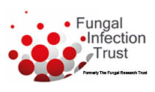
Fungal Infection Trust (FIT) Geoff Scott Travel Funding Application Form

Please complete this form and send to:
John Morgan, FCMA, CGMA
The Fungal Infection Trust, Charity No: 1147658
A Company Registered in England & Wales No: 08031174
20,Elsdon Place, St.Georges Wood, Morpeth, NE61 2GY
secretary@fungalinfectiontrust.org

1.Application Date
2. Conference/Course Title

3.Academic Institution
4. Personnel –
Who is attending?
Date?

5. Aims and Objectives
Aims
Objectives

6. Simple summary

7. Background and rationale – to include the relevance and applicability of the research, medical potential/importance/innovation. How does this work align with FIT strategy?
relevance and applicability of the research
medical potential/importance/innovation
How does this work align with FIT strategy

8. Financial Details
Conference/Course Registration Fee
Travel
Accommodation

