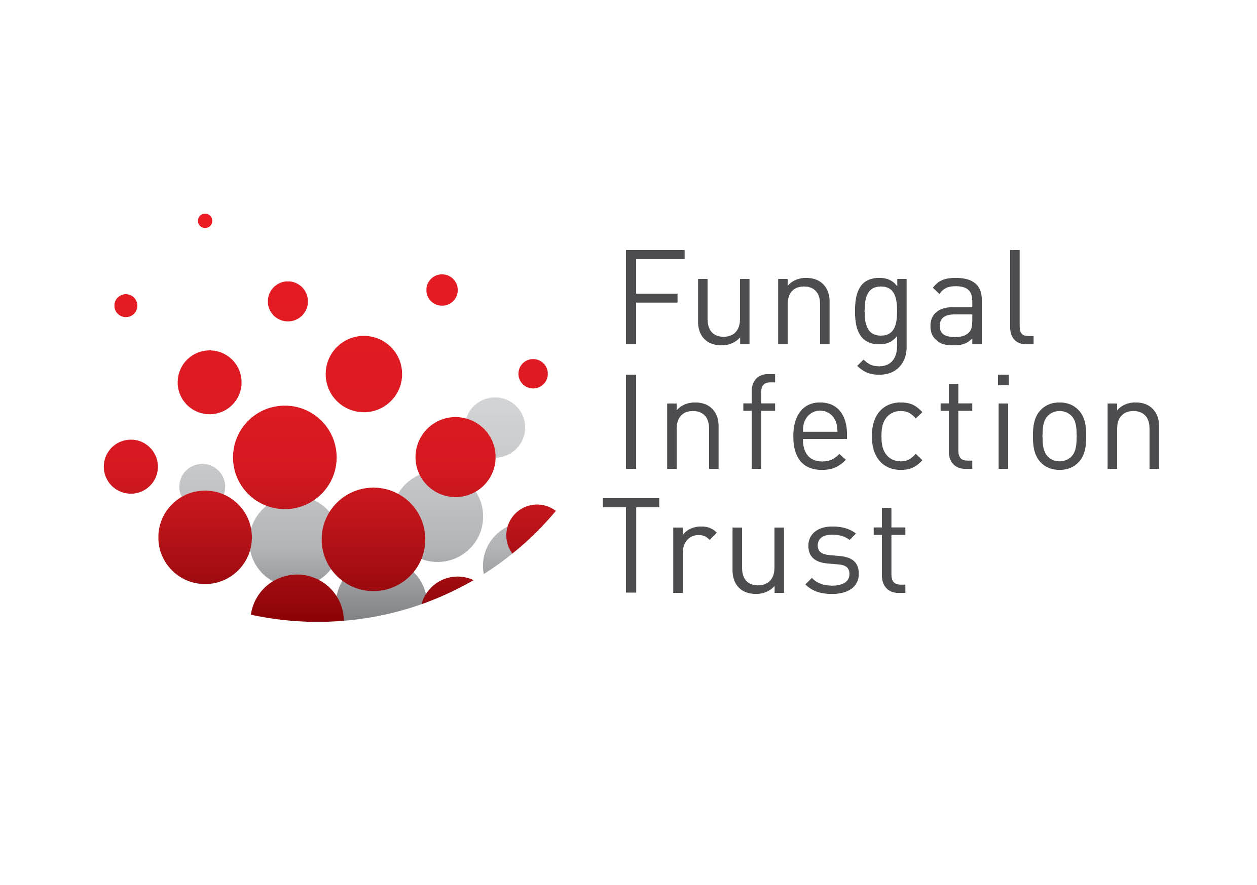
Fungal Infection Trust (FIT) Research Funding Application Form

Please complete this form and send to:
John Morgan, FCMA, CGMA
The Fungal Infection Trust, Charity No: 1147658
A Company Registered in England & Wales No: 8031174
PO Box 482, Macclesfield, Cheshire, SK10 9AR, UK
secretary@fungalinfectiontrust.org

1.Appication Date
2. Research Title

3.Academic Institution
4. Personnel –
Who is in charge?
Who will be carrying out the work?

5. Aims and Objectives
Aims
Objectives

6. Simple summary

7. Background and rationale – to include the relevance and applicability of the research, medical potential/importance/innovation. How does this work align with FIT strategy?
relevance and applicability of the research
medical potential/importance/innovation
How does this work align with FIT strategy

8. Study design - type of research eg laboratory, feasibility study, RCT etc.

9. Research duration

10. Proposed Start Date

11. Methods

12. Financial details

